Test Report for CONQT Pages and APIs

1. Home Page: <https://www.conqt.com/>

Status Code: 20

Result: Passed

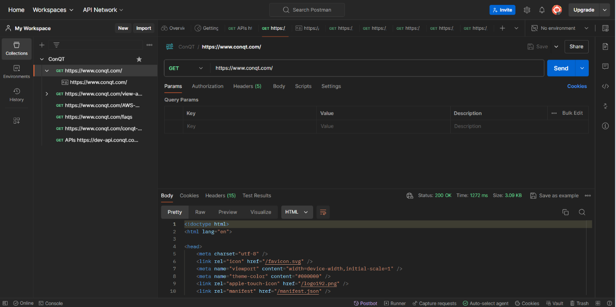

1. View All Products Page: <https://www.conqt.com/view-all-product>

Status Code: 200

Result: Passed

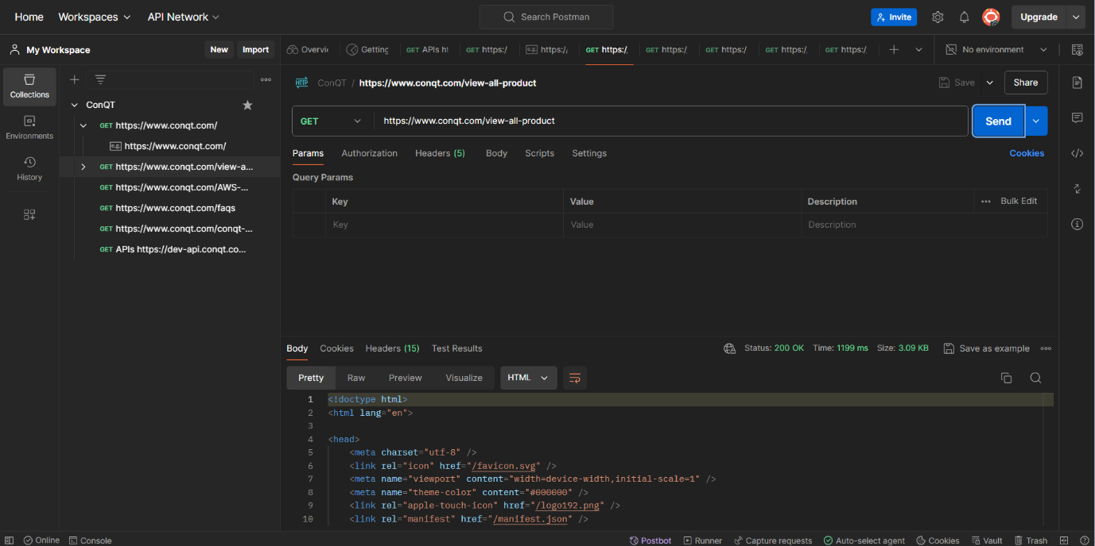

1. AWS Cloud Storage Page: <https://www.conqt.com/AWS-Cloud-Storage>

Status Code: 200

Result: Passed

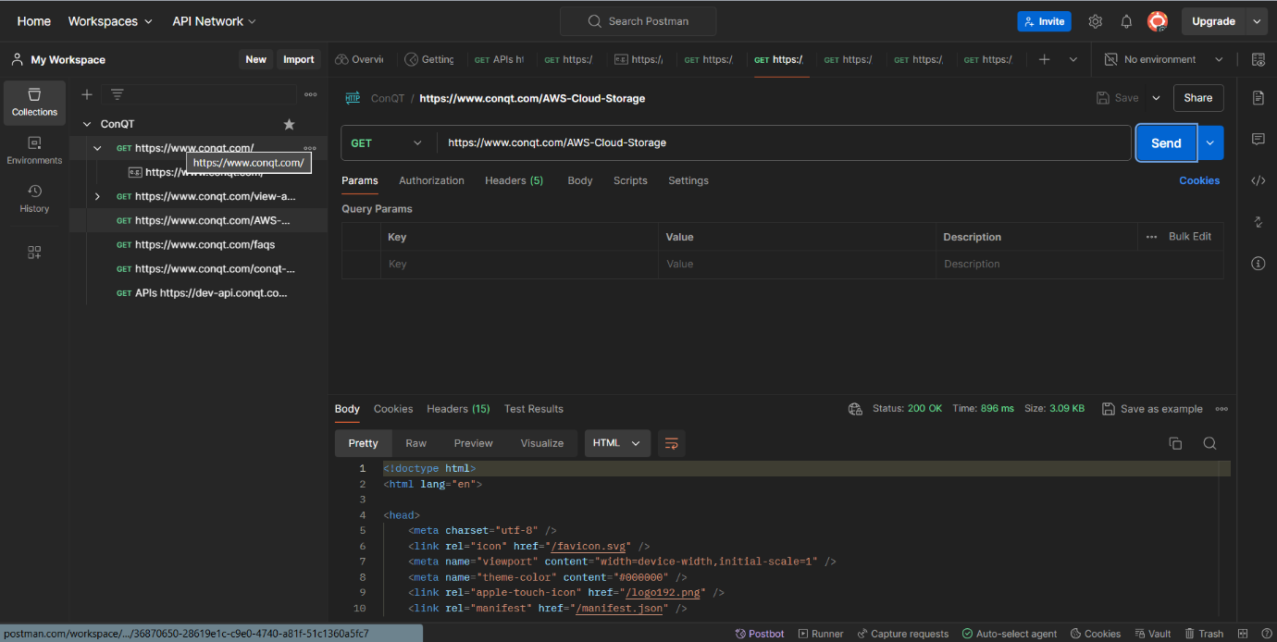

1. FAQs Page: <https://www.conqt.com/faqs>

Status Code: 200

Result: Passed

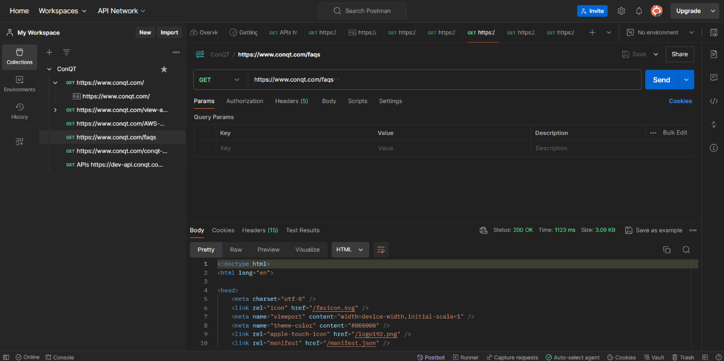

1. CONQT University Page: <https://www.conqt.com/conqt-university>

Status Code: 200

Result: Passed

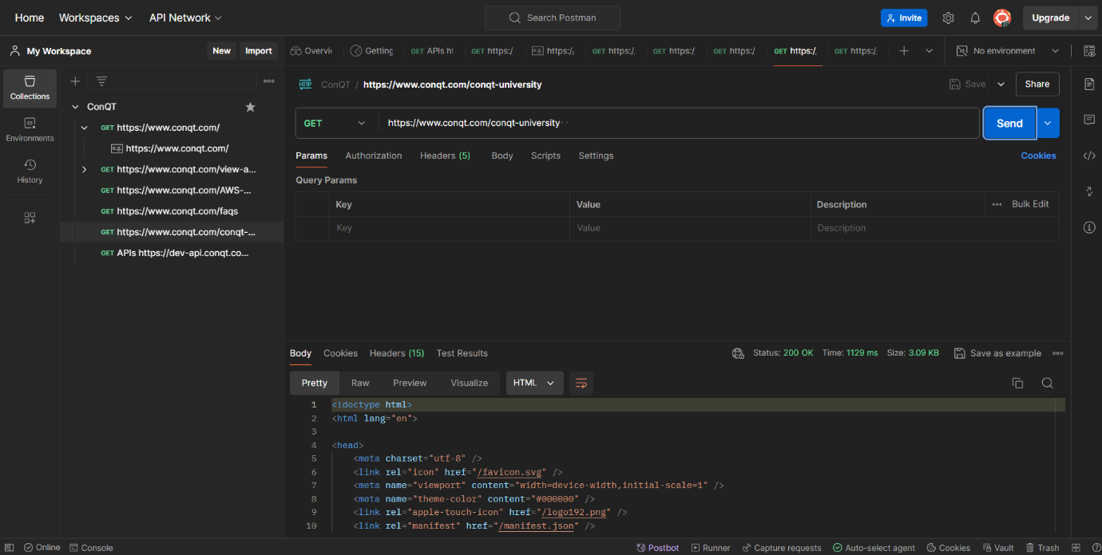

* Get All Products API: <https://dev-api.conqt.com/api/product/Get-All-Products>

Status Code: 200

Response Body: Matches expected schema

Result: Passed

